Project Awesome

Reward Events Document

**Table of Contents**

1 Introduction 3

2 Design Goals 3

3 System Behavior 3

4 Logical View 4

4.1 High-Level Design ……………………………………………………………… 4

**4.2 Mid-Level Design** ……………………………………………………………..... **4**

4.3 Detailed Class Design for Project Awesome ………………………………….. 5

Change History

**Version:** <0.1>

**Modifier:** <Brandon Coates>

**Date:** 23/02/2021

**Description of Change:** First Edition for Alpha 1

**Version:** <0.2>

**Modifier:** <Brandon Coates>

**Date:** 12/04/2021

**Description of Change:** Implemented Recommended Changes to Charts and Information

# Introduction

This document describes the architecture and design for Project Awesome being developed for Team Awesome. Project Awesome is a Single Player casual puzzle game.

The purpose of this document is to describe the architecture and design of the Reward Events which will be the most important feature to reward players

# Design Goals

The design priorities for the game system are:

* The design should be highly open to iterations and changes, with no problems of duplicated objects.
* The provide a moment of humor.

# System Behavior

The game is built with only a single level completed. The complexity of the system is causally related to the limited scope of the project. If there were more levels to be added, along with more puzzles the amount of unique Reward Events would increase.

# Logical View

## High-Level Design (Architecture of the Entire system)

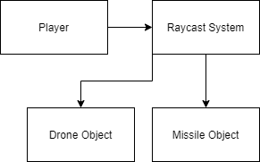

* The Player module is the main module.
* The Raycast module is based on the Unreal Engine Raycast system. The Raycast system is used to initiate events.

## Mid-Level Design

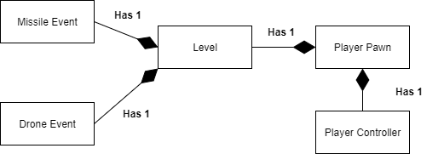

* Reward Events spawn directly in the level because they act as rewards for the player, after they complete a mini-game or find an easter egg.
* The current two Reward Events are the pizza delivery drone and a missile. Both of which the player could spawn if they met the requirements.

## Detailed Class Design of Project Awesome

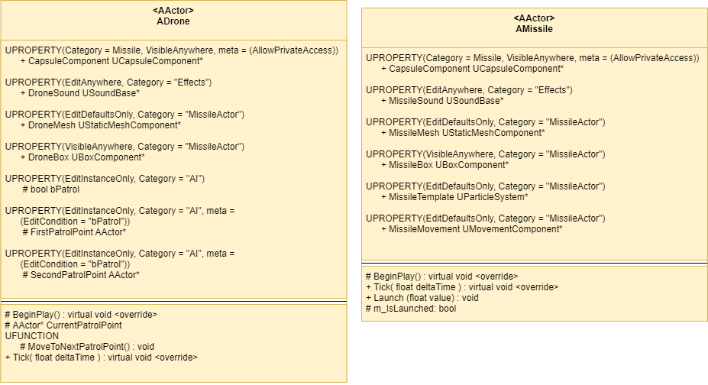

See Mid-Level Design for details.

## Use Case of Reward Event

* The player uses their raycast to collide with a button object which in turn launches the missile.
* It is meant to be a “whoops” funny moment as a reward to the player.